First Maven Project

# Configure Maven Plugin

1. Open STS
2. Window->preferences

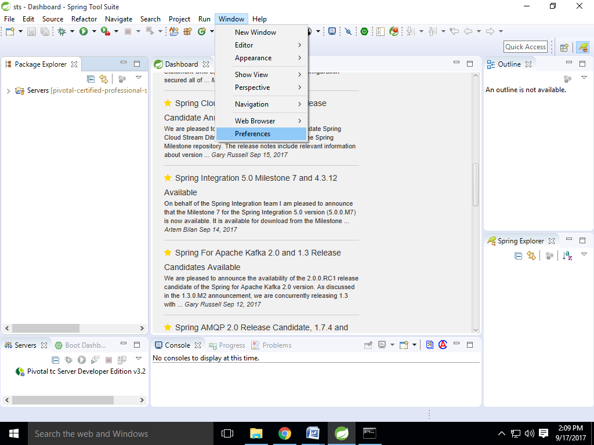

1. Select Maven
2. Check Download Artifact Sources
3. Check Download repository index updates on startup
4. Apply and Close

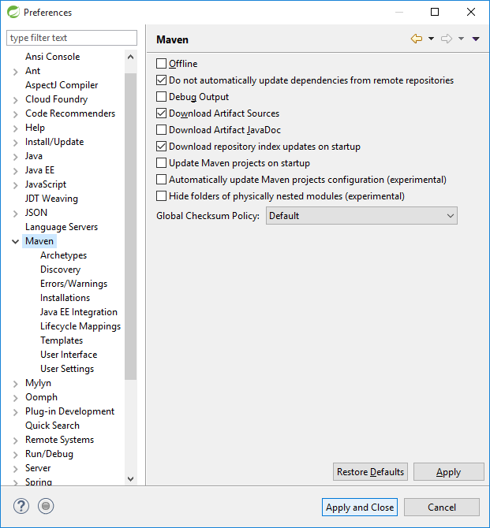

1. Restart STS

# First Maven Project

1. File-> New-> Other
2. Select Maven -> Maven Project
3. Next
4. Next
5. Select Group Id org.apache.maven.archetypes and Artifact Id maven-archetype-quickstart
6. Next
7. Group Id com.corespring.learning
8. Artifact Id firstmaven

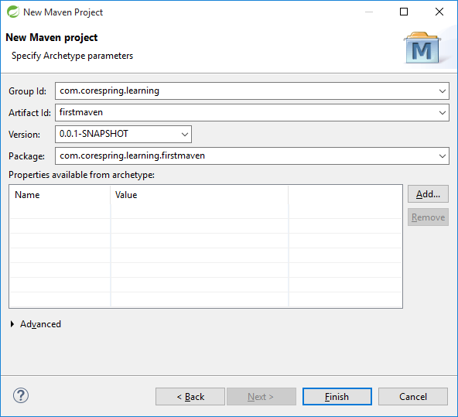

1. Finish
2. Wait Sometimes. Because it is creating Maven Archetypes first time. Please notice the red mark below.

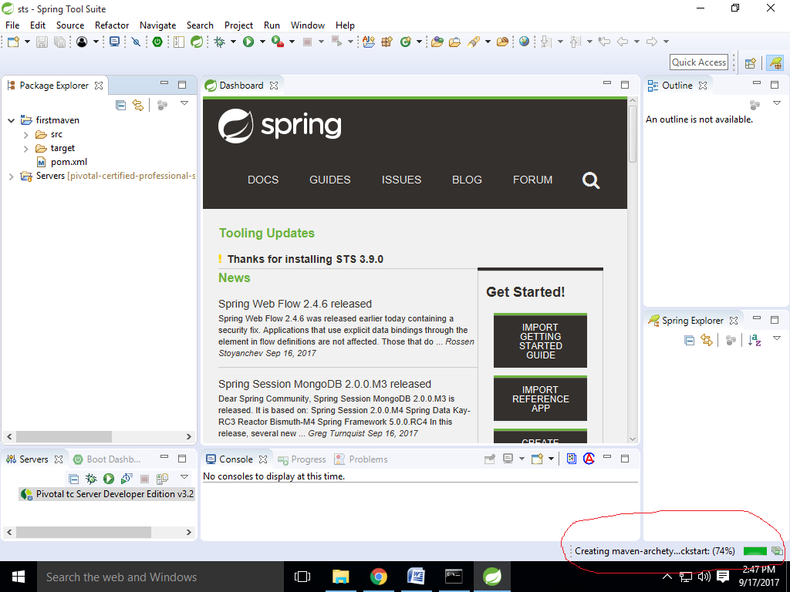

1. Finally our project looks like

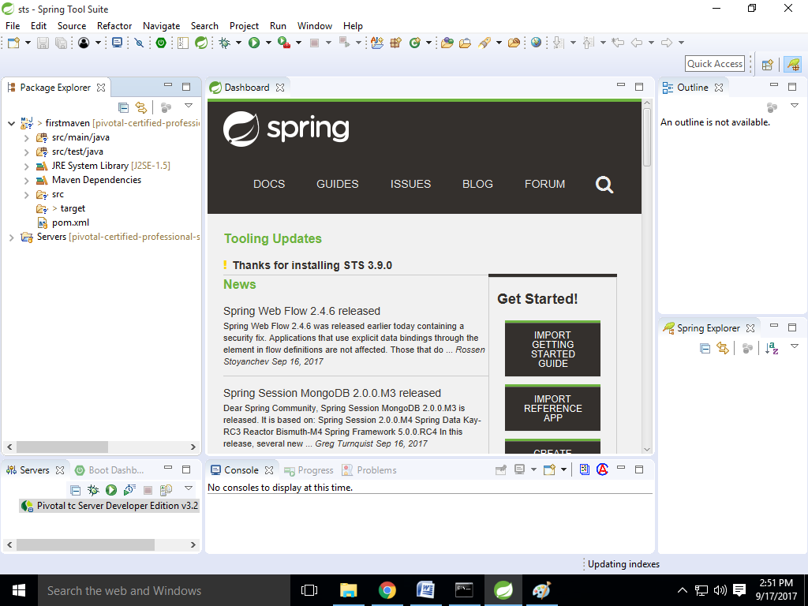

# Add new dependencies

1. Double click on pom.xml

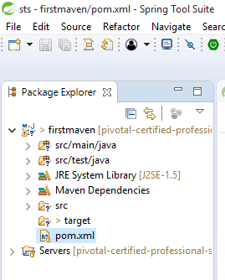

1. Click dependencies

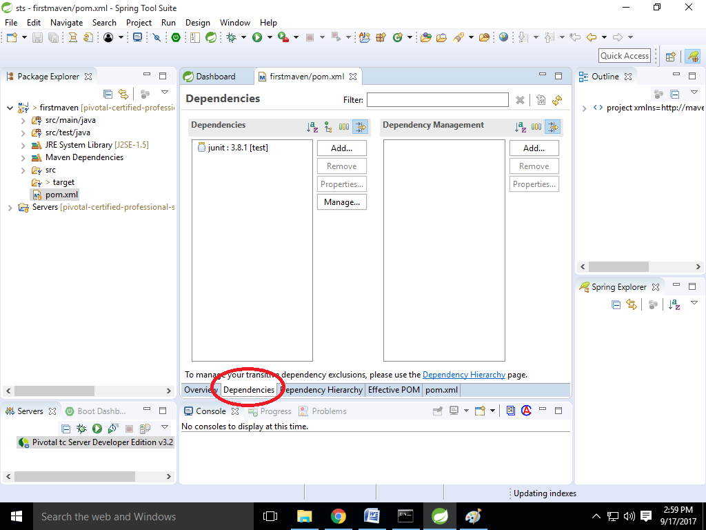

1. Click Add

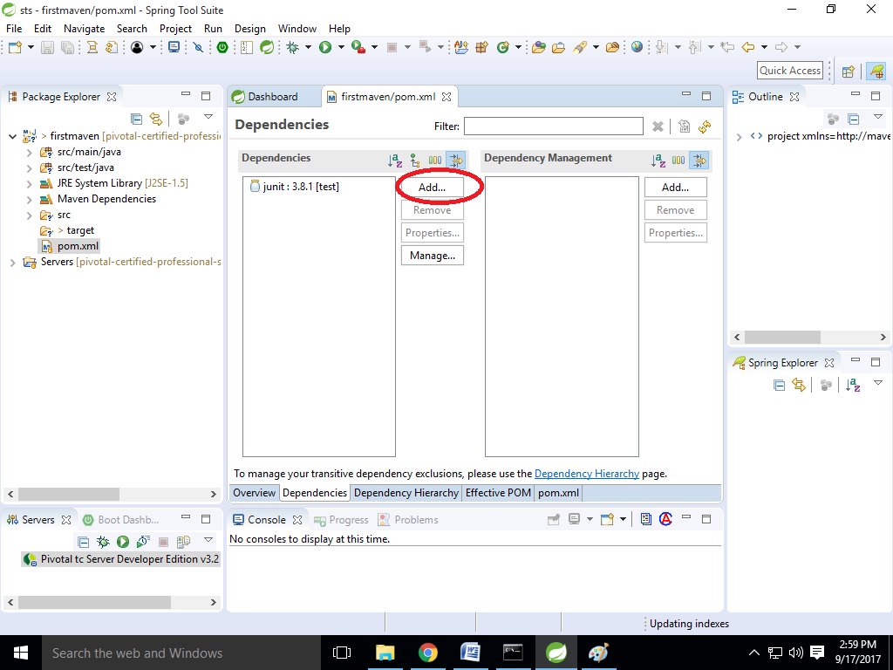

1. Type springframework

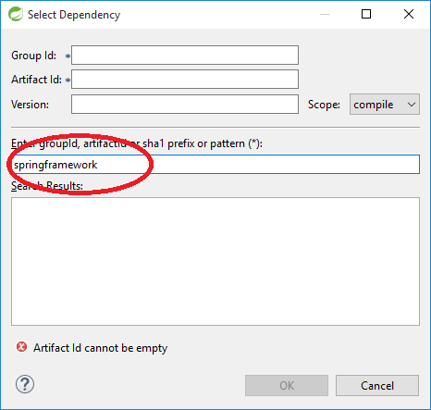

1. Select spring core 4.2.9

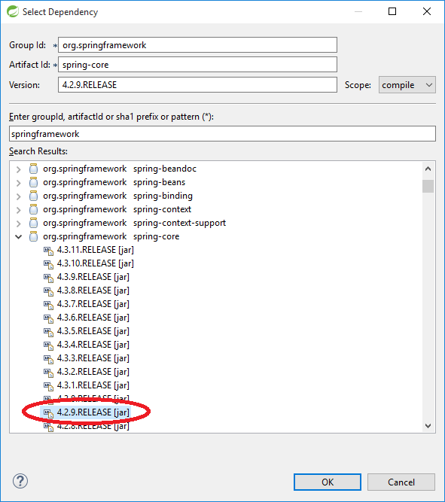

1. Then click on save menu and it will build the workspace
2. After build we will found the jar at Maven Dependencies folder

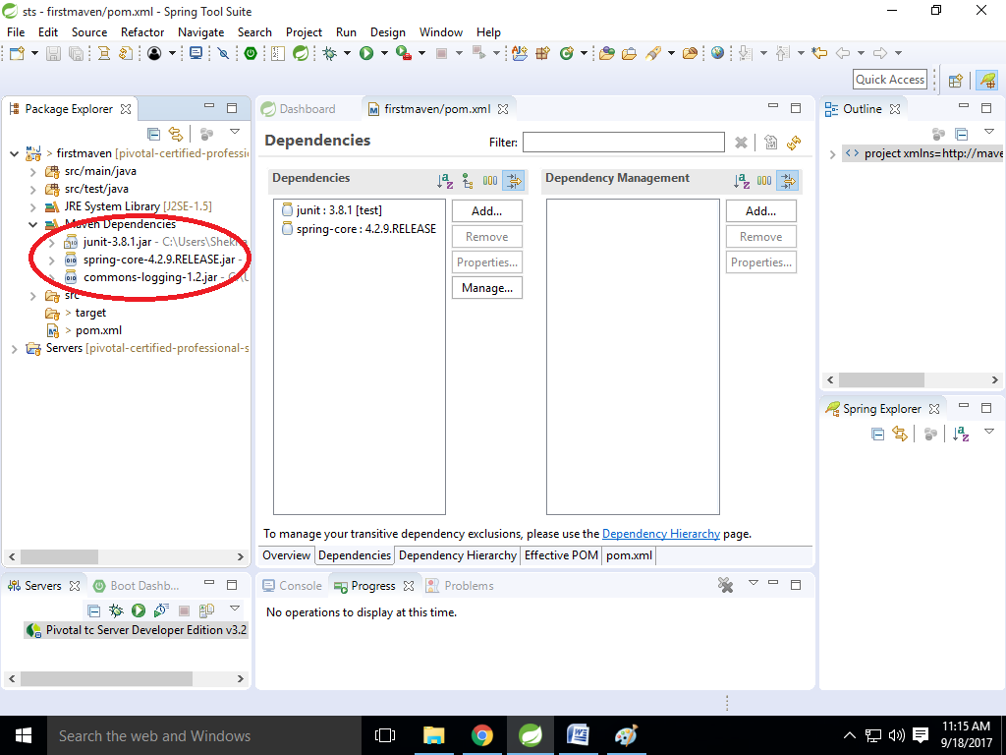

1. And our pom.xml looks like this

